Author
Institutional Affiliation
Instructor
Course code
Date of submission

Impact of scientific research in health improvement.
Genetic engineering has continued to result in various innovations and improvements in the existing technology to improve the life of human beings. Some of these innovations have resulted in improved food security worldwide. Some have received a lot of criticism for exposing humans into various types of cancer and other health issues. The question therefore arises, what way with genetic engineering. Cardiovascular disease has been reported to affect around seventeen million individuals in the United States. This necessitates scientist innovations to the existing treatment mechanism to respond to this pressure in society. Adult stem and the Progenitor cells are possible solutions in improving pre-clinical approaches that can eradicate heart diseases such as cardiovascular.
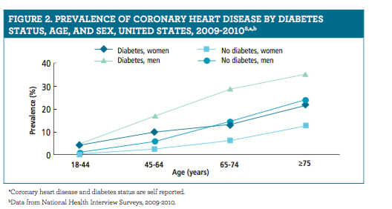
Such recent developments in the health sector is an indication that manipulation of the resources that are already available. The prevalence of heart diseases in the larger society has been raising concern from both a scientist and public health policymakers. The disease does not discriminate who to attack since the young, as well as the old, are equally affected by the same. (Sequeira et al, 2011) argues that the use of cell therapy for cardiovascular patients has proved to be one of the few methods that can be used to counter the spread of the heart condition around the world. While the citizens should practice good nutritional behaviour and change of lifestyle, medical solutions also need to be availed for patients to get another opportunity in life. This approach aims at improving the morbidity and mortality of the myocardial ischemic events.
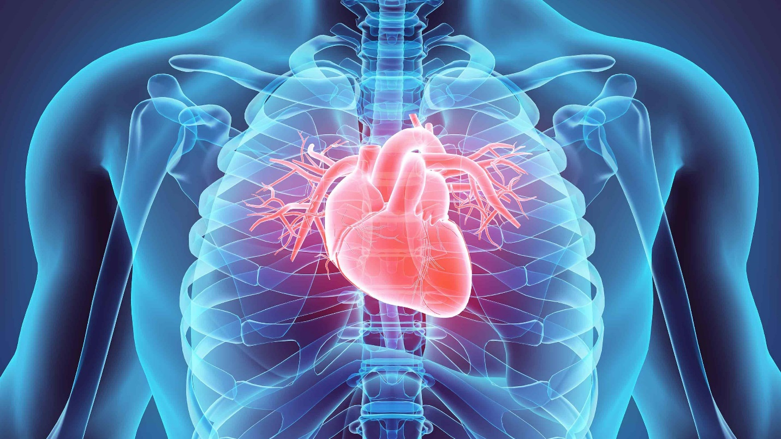
Acute Myocardial infections. When the bone marrow cells are injected to the infarcted myocardium promotes the reconstruction and hastened recovery after infarct (Sequeira et al., 2011). Inflammation can also be improved through the bone marrow-derived cells because some of the activities encourage myocyte regeneration. This development indicates that science has the potential to address some of the existing and future challenges that threaten the life of human beings. There is an increased campaign for universities and other higher education institutions to invest heavily in research which is the only way to ensure that better and new approaches to handling some of our existing problems are identified. The university students are therefore encouraged to spend most of their time in the laboratories and research to identify a way of dealing with the common challenges in society.
The study shows that patients cardiovascular disease and when the EPCs were introduced into the rats they accumulated at the focus of the ischemic area. This study on rats identified that similar response in dealing with similar patients could rely on this kind of transplant to facilitate speedy recovery of the patient suffering from such conditions of the heart. According to Sequeira et al, (2011) the delivery method of therapy plays an important role in the success of the mentioned therapies. Both intravenous infusions have proved to be the most convenient but cannot be applied in other organs. Field research and analysis of the observation plays an important role in identifying the best approach of delivery and treatment therapy for a specific health disorder. The advancements made in the medical world cannot be final because as the time goes, the cells develop new adaptations that can either reduce or improve their immunity. The continuous study is therefore recommended especially in health facilities to identify some of the relevant approaches.

REFERENCES.
Sequeira, C., Park, K., Pepine, C. J., & Cogle, C. R. (2011). Stem and progenitor cell therapies for cardiovascular disease. J Cell Sci Ther, 1, 001.

